**CALMATEO MARKJOMAR SANJUAN. DEC 15, 2022**

**BS IN INFORMATION TECHNOLOGY CC101**

**SUMMARY REPORT**

(Webinars and seminar)

**FUNDAMENTAL PC HARDWARE INSTALLATION AND REPAIR FOR OSY**

(ILCD_CO-dipSCHIROCY_2022-02)

OCT 26-28, 2022

8:00 am to 12:00 noon

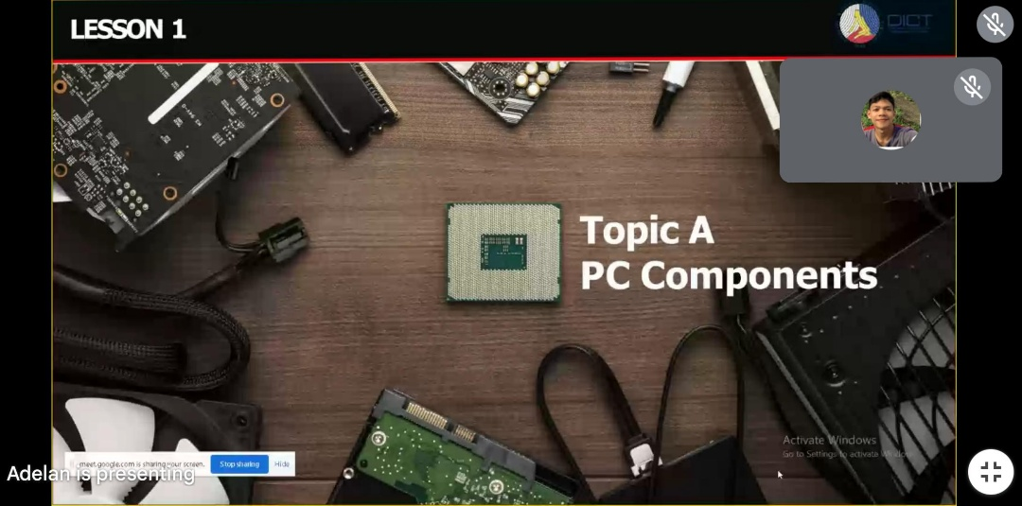

The topic **PC COMPONENTS** is all about the discussion of the **hardware** and **software**, the meaning and the functions of the all **input** and **output** devices are successfully discuss.

I learned a lot of learnings to handle a device carefully, hopping that soon i can apply all the skills that I learned in this topic.

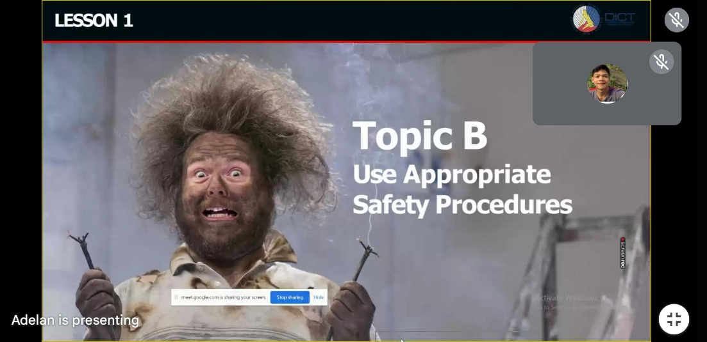

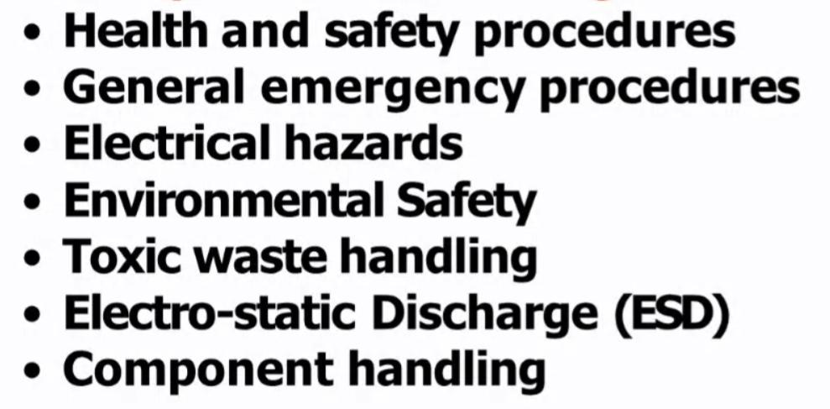 The 2nd Topic is the **“Use appropriate Safety Procedures”** on this topic they discuss the…

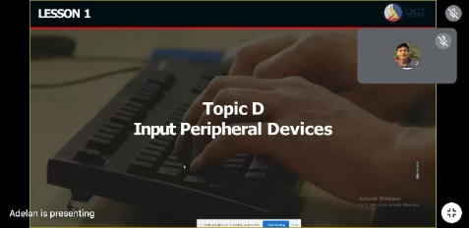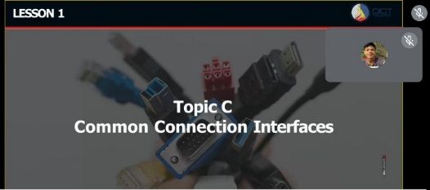I lerned so much in this topic because it is about our safety ang health that can save our lives sometimes.

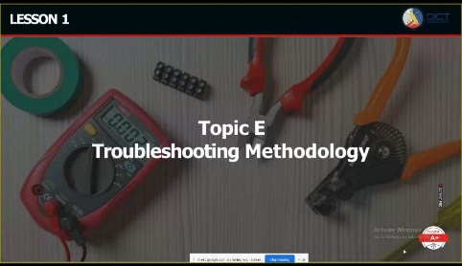

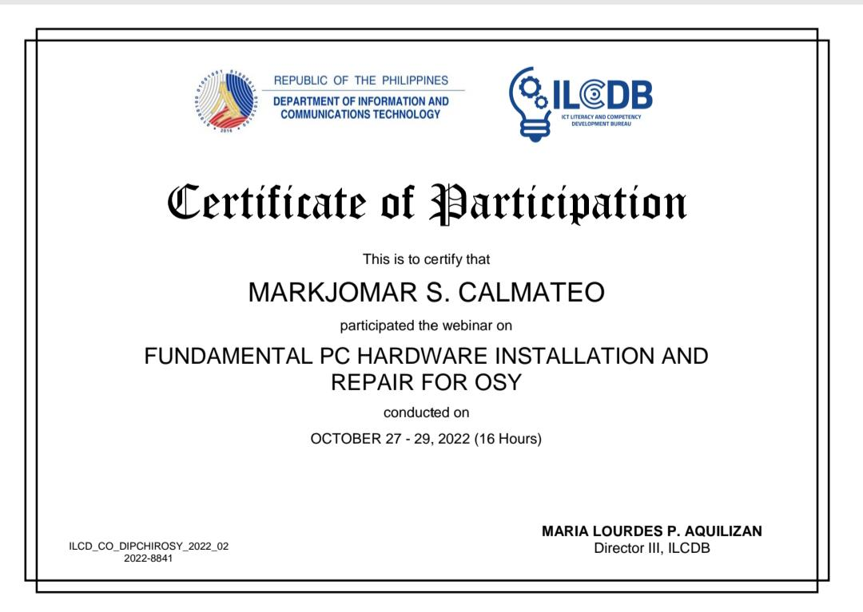

November 24, 25 2022 ILCBD send a certificate to all students that participate on the webinar Im so thankful for this certificate ,and also thankful for all the knowledge that we learned.